Software Design and Developement
SOFT40141: 202425 Half Year 2
Patryk Nowak N0944598

Contents
Introduction (Description of System) 2
Design 2
Use case diagram 3
Class diagram 4
Sequence diagram (Updating Project Progress) 5
Component diagram 5
Deployment diagram 6
Functional Requirements 7
Design pattern 7
Tutorial 7
Database Setup 8
Program 8
Testing 11
Conclusion 12
References 13

Introduction (Description of System)
The program developed for XYZ Company consists of several key elements for project management. The main user interacting with the program will be a regular team member, upon logging into the program they will be able to choose between different tasks assigned to them, make progress reports about the tasks and mark the tasks as completed. This allows them to work alongside having the program open and seeing exactly what they need to do whilst also making date stamped progress reports which project managers and administrators can see. They can also dynamically see which project they are working on depending on the current task they are doing.
The next user interacting with the program is a project manager. They are able to see the current Project Assigned to them, its description and progress to completion at all times. They are able to update the project’s progress to their discretion. They are also able to view the comment logs left by team members which includes the creator of the comment, title, description and the date it was submitted. They are finally also able to assign their project’s tasks to regular team members. They can do this by selecting the task within the project (they can’t choose tasks outside their project) which then displays the title, description and if applicable, the current assigned team member. Afterwards they can select an employee to assign and then assign the employee to the task or re-assign a different employee to an already taken task.
The last menu of this program is the administrator menu which houses management tools for the projects themselves. To begin, they are able to also view the comment logs left by regular team members with the same parameters. They are able to view projects by their ID numbers which displays all of the project one ID number at a time. This includes the title, description, project status, and the manager assigned. Naturally all of these fields are also completely edditable for the administrator who is able to change everything but the ID number of the project with some limitations. The only parameters they can’t freely change is the project manager who must exist and must be available as only one project manager can work on one project. Theres a constantly updating list next to the project view which shows available project managers that can be assigned. After the administrator makes all the changes they see fit they can press the update button which updates the database with the newley edditted project. The administrator can also delete a project with the delete button using the ID of the project. Or the Administrator can create a new project by editting the fields (new ID is generated automatically) and clicking the create button. The administrator can also manage the tasks associated with current selected project with the same actions as the project. They can delete, update and create tasks, only they can’t assign the tasks to team members, that is left to the project managers to do.

Design
5 different diagrams were created to design and prototype this project which helped immensely when coding it. These diagrams were the Use case, Class, Sequence, Component, and Deployment diagrams.

Use case diagram
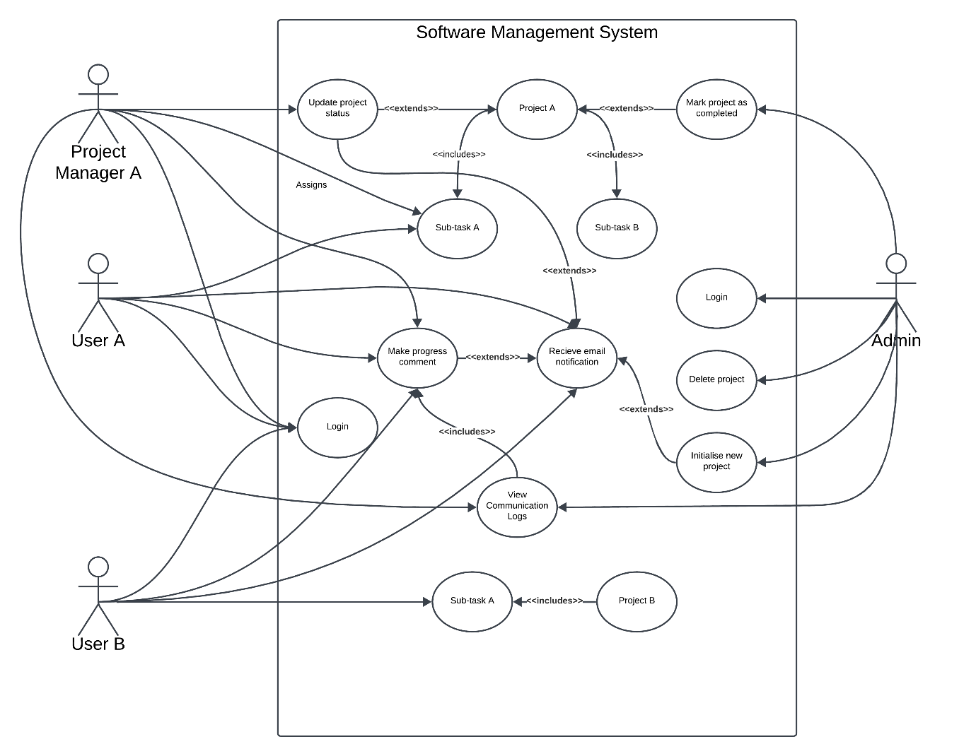
Figure 1 shows the final use case diagram which helped outline the basics of what the project set out to do. For example, the admin does 4 things, Login, Delete project, initialise new project, Mark project as completed. In the final version of the project the admin logs in, deletes projects, creates (initialises) new projects, can mark projects as completed and they can also update projects and do all those functions on tasks related to those projects. However, receiving email notifications was never implemented and project managers aren’t able to make progress comments.

Class diagram
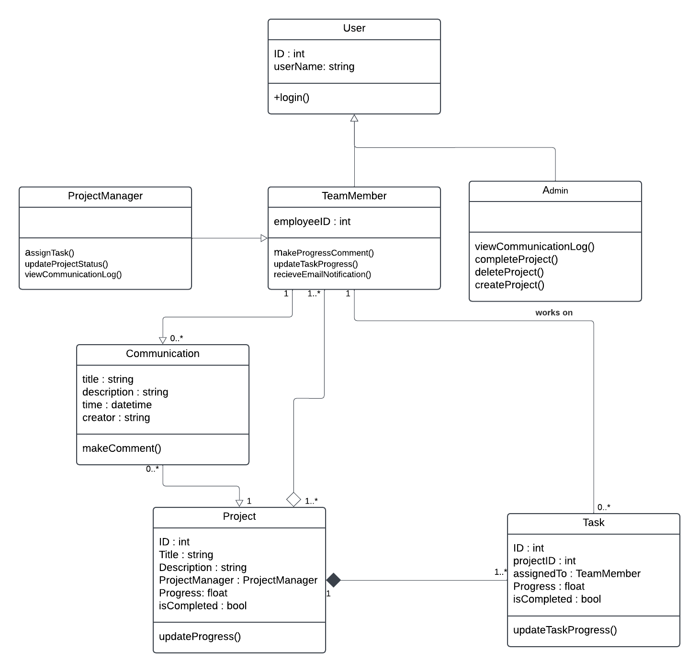
Figure 2 shows a class diagram which was the main basis for the sequence and component diagrams. It has some outdated attributes such as the project isCompleted : bool which were in the actual program for a while until it was deemed unnecessary when in practice. Also, some functions are missing which were added in the program like admin being able to update tasks.

Sequence diagram (Updating Project Progress)
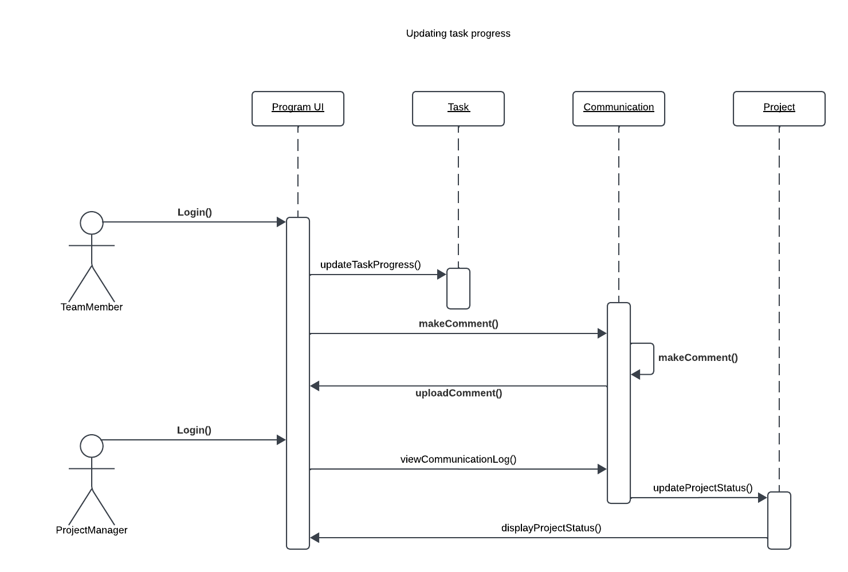
Figure 3 shows the sequence diagram for updating project progress from the perspective of a team member and project manager. It shows that a user must first update their task progress and make a comment after which a project manager can read that comment and accordingly update the project status. It works differently in the program; however, it can still work like this.

Component diagram
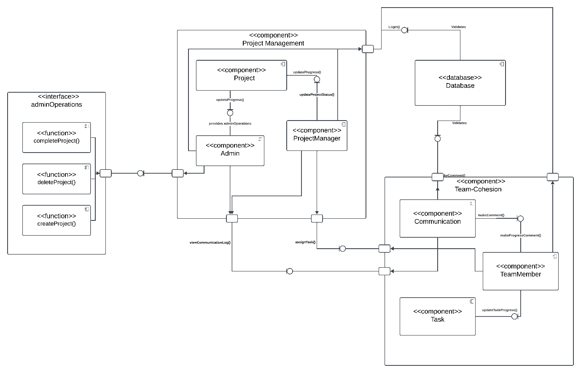
Figure 4 shows a component diagram which most closely resembles the finish project in terms of features, functions and paths. Its mostly split into 2 main components, the Team-Cohesion and the Project Management with the other 2 smaller components being adminOperations which links to the admin directly and Database which links to both major components respectively.

Deployment diagram
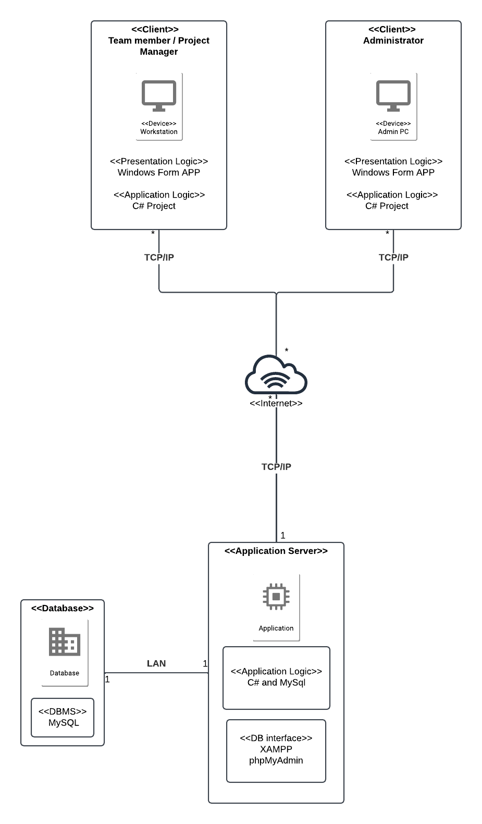
Figure 5 is the deployment diagram which shows how the software would be physically run on hardware when deployed. This shows the database using MySQL and the application server which uses phpMyAdmin to manage the database. This is then sent to the Client over the internet which receives the information presented through a Windows Form Application on their device.

Functional Requirements
- The program will allow users to log in.
- The program will show users the appropriate interface based on their role.
- The program will display tasks assigned to the logged-in team member.
- The program will allow a team member to mark a task as completed.
- The program will allow a team member to submit progress comments.
- The program will allow project managers to view their assigned project title, description and status.
- The program will allow project managers to update the status of their project.
- The program will allow project managers to view the comment Log.
- The program will allow project managers to assign tasks in their project to team members.
- The program will allow administrators to create, edit, and delete projects.
- The program will make sure that each project has a valid and available project manager assigned.
- The program will allow administrators to manage tasks within projects (create, update, delete).
- The program will allow administrators to view the comment Log.
- The program will allow users to log out and return to the login screen.

Design pattern
The project design pattern can be most accurately described as following a simplified MVC design mostly being a simple layered architecture using the 3 tiers. The Model is best represented by the Query data class and the separated database connection class as well as the objects based on the User, Project and Task classes. Whilst the view layer consists of the several windows forms which give the user information through the UI. The controller layer is embedded within the windows forms event handlers and model layer functions. It’s not a strict MVC layout and its loosely based on the 3 tiers especially the controller layer.
However, because it is a smaller project based on windows forms the lack of a concrete controller layer is helpful for code simplicity and speed. Due to not having to make a full controller layer the project was created a lot faster and simpler due to not having to separate small amounts of code between the layers where it realistically didn’t need to. Aside from that the windows forms architecture heavily discourages a controller layer due to its event-driven nature, it handles both the interface and input made by users naturally. Creating a separated controller layer would very often complicate the simplicity provided by windows forms and would lead to the program being bloated with unnecessary code and complexity. Making the code more complex would also make it harder to understand and maybe more prone to break when something gets changed.
Due to this reasoning A strict MVC design was not fully followed due to the reasons outlined earlier, however, it still resembles a tiered MVC architecture and there are still merits to loosely following the architecture even when using windows forms that don’t handle a controller layer well.

Tutorial
This will be a short tutorial on running the program from the ground up including database setup.

Database Setup
To run this program the user must first setup up phpMyAdmin on their web browser as that’s the intended SQL solution used in the program. The easiest way to do this is by downloading and setting up XAMPP.
https://www.youtube.com/watch?v=UjAbsItMPRY&ab_channel=AmitThinks
This YouTube tutorial (Amit Thinks, 2024) shows exactly how to install the database and use it to access phpMyAdmin. The next step is importing the database provided in the project files. The file is labelled “sdd_db.sql” and will be located SDD-Project\sdd_db.sql in the project file.
https://www.youtube.com/watch?v=OEyr-evubS8
This YouTube tutorial (WebTechKnowledge, 2024) shows how to import the database into phpMyAdmin.
After the database is all imported and started the user may open the project and make sure the database connection string (connString) in Program.cs is correctly configured for the user.
Alternatively, the user may also decide to use a different database solution which is not recommended but possible if the database file is converted to a different database solution, the correct database packages are installed, and the affected code is changed to accommodate the new database packages.

Program
The program is split into 3 main menus, the team member menu, project manager menu and administrator menu. The user must first login on the login menu using their username and depending on the role of the user, 1 of the 3 menus will be shown. The menu to be explained is the Team Member Menu as shown in Figure 6.
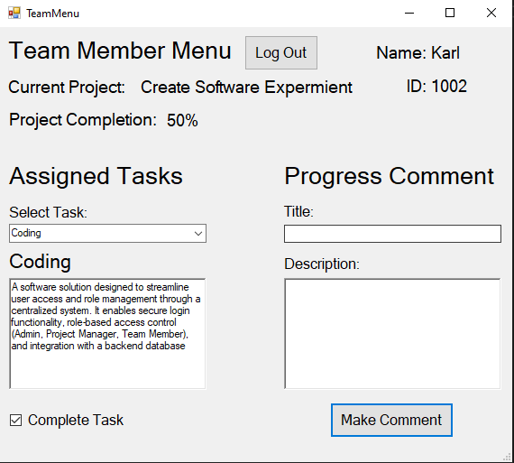
The Team Member Menu allows the team member signed in to view the current project and its status depending on the selected task. If the team member swaps to a task from a different project, the project title and status update. The team member can select a task upon which it will display the name and description of the task below it with the option to complete the task for the user. If the user completes the task, it gets updated on the database. The user can also create a progress comment with the option for a title and description, when the team member presses the make comment button it will save a new row in the communication table with the title, description, current user’s name and the date it was made.
The next menu is the project manager menu which displays when a project manager logs in as shown in Figure 7.
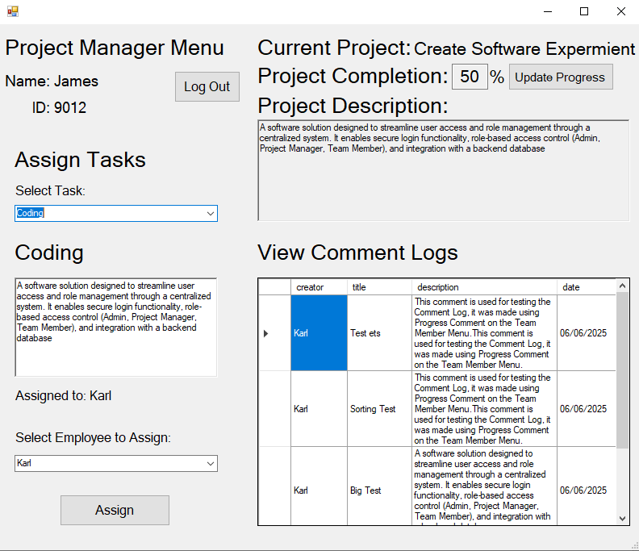
On this menu the project manager can view their currently assigned Project, its status, and the description of it. The project status can also be changed and updated by the project manager. The project manager can view the comments in the comment logs section made by team members. They can also assign tasks to the team members. First, they must select a task which displays the same information as it did for the team member and who the task is assigned to (if it is assigned). They can then select and employee and assign them to the task overwriting the previous team member on it.
Lastly the administrator menu which is shown in Figure 8.
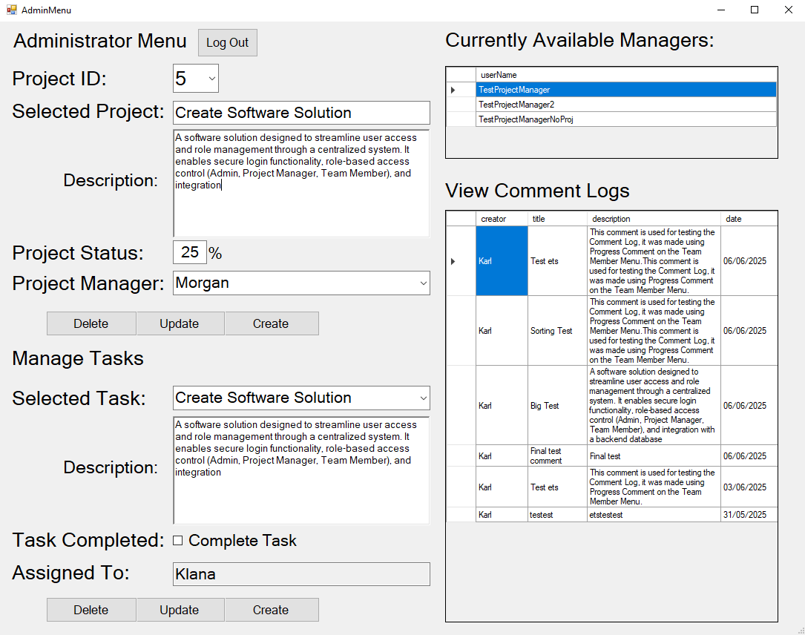
This menu allows the administrator to view the comment logs like the project manager. It also allows the admin to select a project by its ID number which then inputs all of the project’s details in the forms below. These forms are editable by the Administrator meaning they can change the projects and using the Update button, upload the newly changed project onto the database. Similarly, they can create a database using the same forms by filling them manually (project ID is automatically created) and creating a new project with the create button. Alternatively, the admin can delete the project using the delete button which will delete the project from the database. The only problem with the update and create functionality, is that the user can’t create or update a task with an already assigned project manager (unless updating with the same manager). That’s why there is a manager list on the right showing all available managers that don’t have a project assigned which can be used to update or create projects. The admin can also perform all the same functions on the tasks associated with the selected project, they can be deleted, created and updated the same way as the project, except they can’t be reassigned. The project manager in charge will have to assign any newly created tasks.
When the user is finished using the program, they can use the Log out button located at the top of the form to quit their menu and go back to the login screen.

Testing
While the project does not make use of any unit testing or other forms of software testing, it does make use of a lot of manual testing methods great for input error handling and validation. These improve the reliability of the code and with the amount implemented it is very pretty difficult to crash the program. Some examples of the manual error handling and input validation can be seen in Figure 9, 10 and 11.
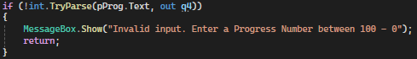
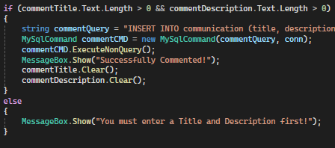
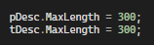
In the first example, it means that if the text box named pProg can’t be parsed as an int its “invalid” and gets ignored with a message box telling the user its wrong and letting them retry. The second exampled shows input validation meaning it won’t allow the user to send an empty comment to the database. In the last example the description boxes for the project and task in the admin menu have a hard limit set to the equivalent value on the database so they can’t exceed the maximum value. This is to prevent an SQL error where the potential UPDATE/INSERT value is larger than the max allowed for that value on the database.
Another form of error handling used in the project were try catch blocks for runtime error handling as can be seen in Figure 12.
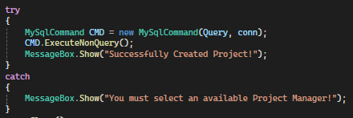
These blocks helped a lot in terms of identifying bad code, misplaced code, in general faulty code/logic. They also helped prevent the program from crashing catching the exception and carrying on, and finally also helping diagnose database issues. Message Boxs were also really helpful to figure out code and troubleshoot it as if the code didn’t work but implementing a Message Box would run, it meant something with the internal logic (functions, wrong function parameters). You can see an example of a Message Box in Figure 12.

Conclusion
To conclude the project Successfully delivers a working functional project management system with the requirements set out by company XYZ’s. It allows project managers, team members, and admins to log in and manage and interact with different levels of information. The simplified MVC structure present in this project plays to UI solution’s (windows forms) strengths by not over complicating the program and keeping most of the controller layer buried within the view layer or model layer. Formal unit testing and other automated testing was not conducted; however, the manual error handling and input validation tests were thorough ensuring the system’s reliability and accuracy. In summary, the project has met all of the necessary requirements set by XYZ Company and has set a good foundation for its project management for the future.

References
Amit Thinks, 2024. How to install XAMPP on Windows 11 (Updated 2025) [video]. YouTube, 9 October. Available at: https://www.youtube.com/watch?v=UjAbsItMPRY&ab_channel=AmitThinks (Accessed 4 June 2025)
WebTechKnowledge, 2024. How to Import a MySQL Database to phpMyAdmin XAMPP [video]. YouTube, Published 8 months ago. Available at: https://www.youtube.com/watch?v=OEyr-evubS8 (Accessed 4 June 2025).

